

The Invasion of Unemployment and Video Games

UCI Data Analytics Boot Camp

By: Gabriel Andaya, Alex Heang

Main Question:

Is there an increase or decrease in video gaming within the United States?

Secondary Question:

What may have contributed to the change?

What type of games were people playing?

1. How many people worked?
   1. Unemployment rate between 2000-2017
2. How many sales of video games were there?
   1. Popularity of different titles throughout the years?
   2. Sales of video games and their corresponding consoles (Xbox, PS, Nintendo) by region
3. What kind of correlations are there between people that work and people that play video games?
   1. Year of game release and unemployment rate

Our goal is to find any correlation between the Unemployment Rate in the United States and the sales of video games in the North American region from 2000-2017. Our research will define high unemployment in the US as any year or month above 5%. Anything below 5% has a low unemployment rate. Video games will be analyzed by their platform popularity and at what years were sales highest inside the US. Platforms include: Xbox360, Wii, 3DS, Xbox, PS2, PS3, etc. A correlation will be presented between unemployment rate by year with the sales of video games in North America by year.

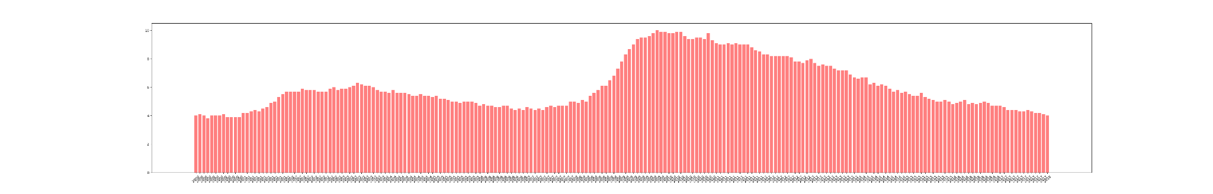

There have been 149 months of high unemployment, and 68 months of low unemployment from 2000-2017. The highest unemployment rate period was 9.8% in September, 2009. The lowest unemployment rate period was 3.8% in April, 2000. We see a relatively high unemployment trend during the early 2000’s, which might be attributed to the dot com bust and then we see the unemployment rate lower during 2003-2008. Then we see the effect of the Great recession from 2008 take a large effect on the US Unemployment rate from 2008 to 2012 and we see a low recovery of the unemployment rate from 2010/2012.

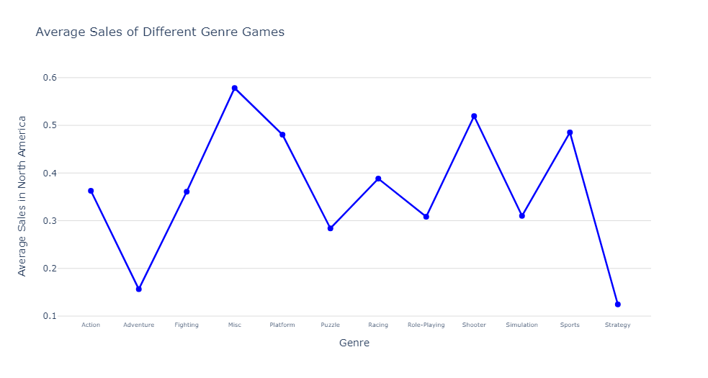

In North America, consumers prefer platform and shooter types of video games. Platform games include games such as Super Mario Bros. Shooter style includes games such as Call of Duty and Grand Theft Auto. These are the types of video games that publishers may focus on developing to better increase their sales in the North American market.



The year 2008 had the most sales in North America with 256.25 million sales, and with 2007 coming second with 235.61 million sales in the region. The year 2016 recorded the least amount of annual video game sales in the North American region with 34.52 million sales. This supports the hypothesis that around 2008 the great recession started and we can see a downward trend in console video games from that point on.

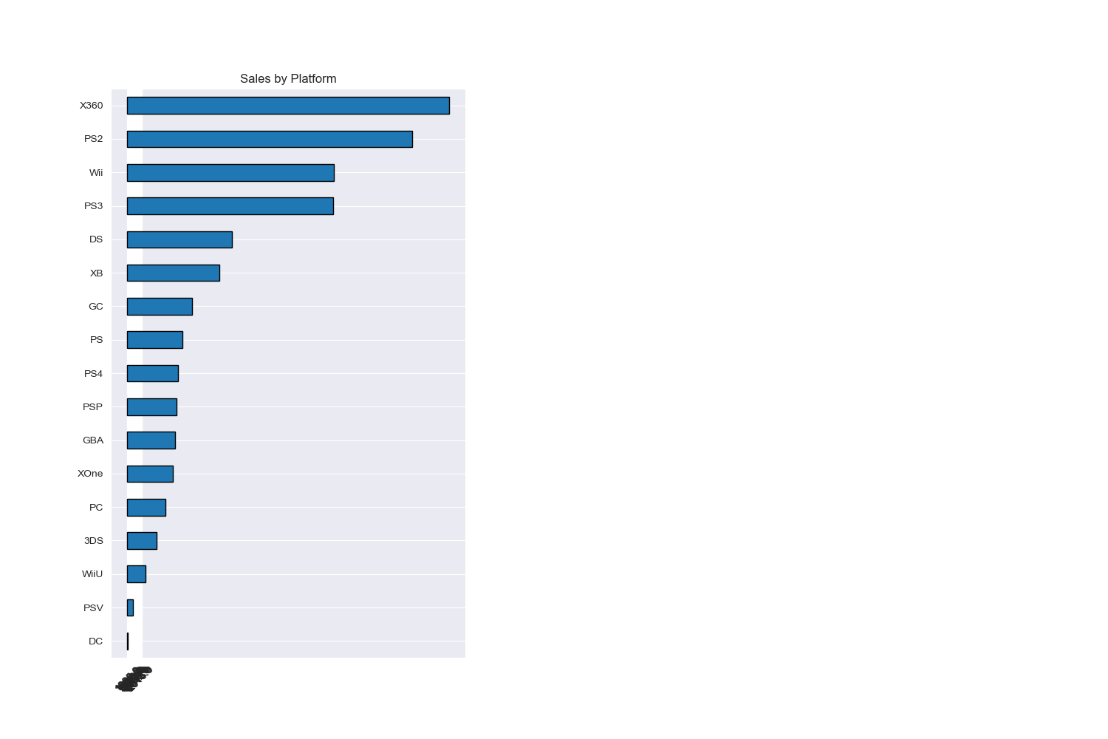

Xbox 360 video games were the most popular in the North America region with 533 million sales from 2000-2017. The publisher of Xbox 360 is Microsoft which is a domestic company of the United States. 2006 saw the highest selling video game with Wii Sports reporting 41.36 million sales in North America. The Publisher is Nintendo from Japan. The five most popular consoles in NA from 2000-2017 were Xbox 360, PS2, Wii, PS3, and DS.

There may be a correlation between the unemployment rate and video game sales. Evidence that helps support this are the decrease in video game sales as the job economy improved, the impact of the 2008 recession where we saw the largest sales volume two years prior (in 2007 and 2008) which was also the start of the greatest job loss in recent history, and in 2001 was the dot.com burst where many tech businesses were shuttered and jobs were lost (a mini recession). We can see a decline in video game sales after this period of time.

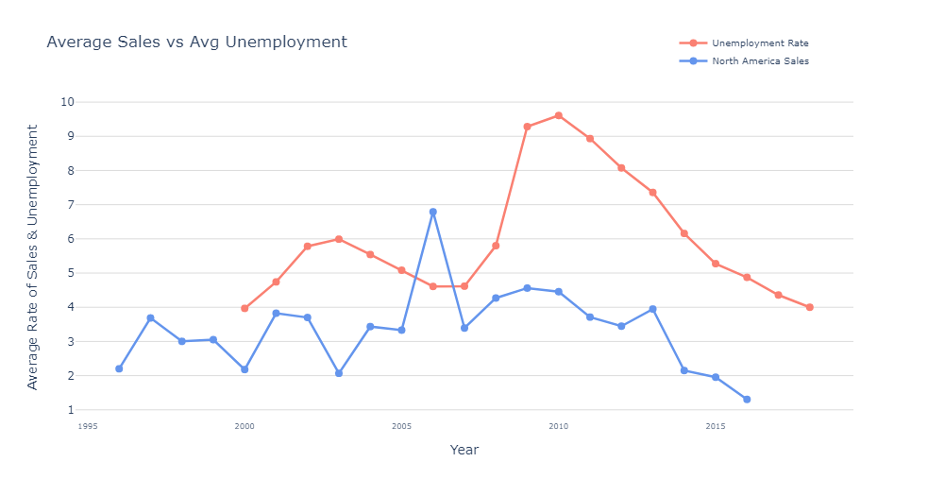

Through merging both csv files, we see from the graph provided that there is some correlation between unemployment rate and video game sales in North America. As unemployment shrinks, sales of video games rise as seen in years between 2005 and 2008. We see as unemployment rises, video games in North America fall, as seen between the years 2001 and 2004. Another instance of low sales or lowering of sales and high unemployment is between years 2009 and 2013 during the Great Recession time frame.

Although we see a correlation between these two datasets, there may be other contributing factors which may influence video game sales. Some of these are: The change in consumer behavior after 2010 from console gaming to mobile or PC gaming as they became more readily available. The growing popularity in casual gaming produced by independent studios which were not captured by these datasets. The advent of cloud video game streaming services and digital purchases.

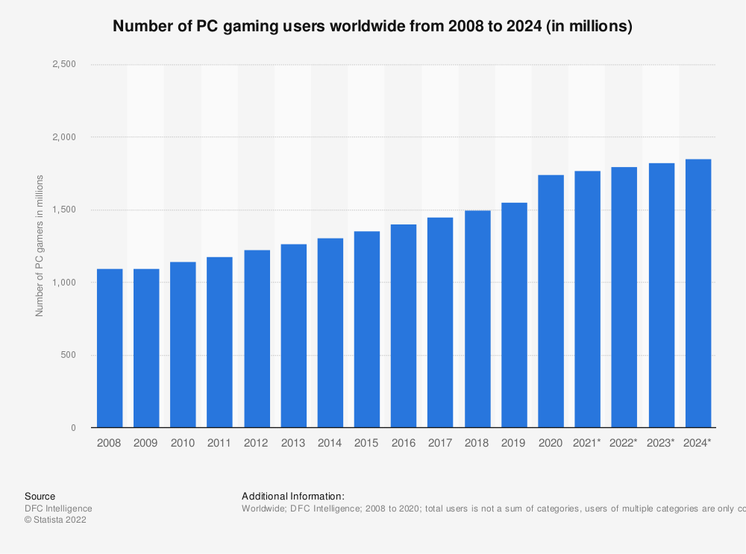

This bar chart shows the growth rate of PC gamers annually from 2008-2024. The information can shed some light onto why console gaming has decreased amongst gamers in our original dataset

**References**

FRED: <https://fred.stlouisfed.org/series/UNRATE>

Kaggle: <https://www.kaggle.com/datasets/gregorut/videogamesales>

GitHub: <https://github.com/Andaya334/Project-1.git>

Statista: <https://www.statista.com/statistics/420621/number-of-pc-gamers/>